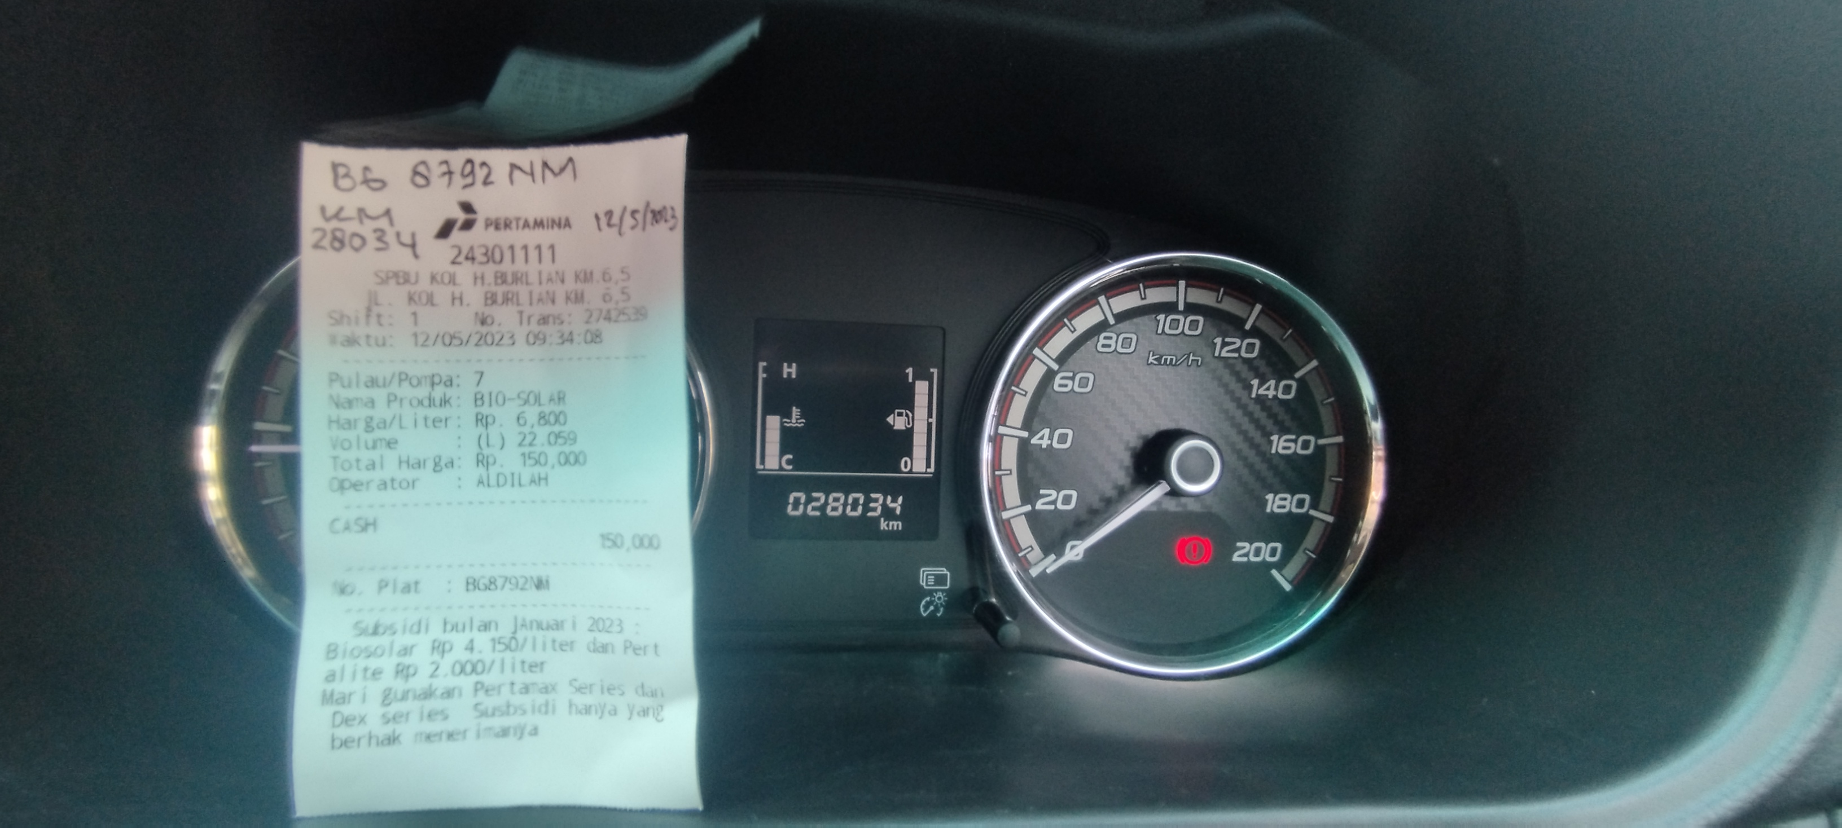

**NOTA SOLAR TGL : 12-05-2023. PLAT BG 8792 NM, KM 28034, RP 150.000.00. 22.05 LITER**

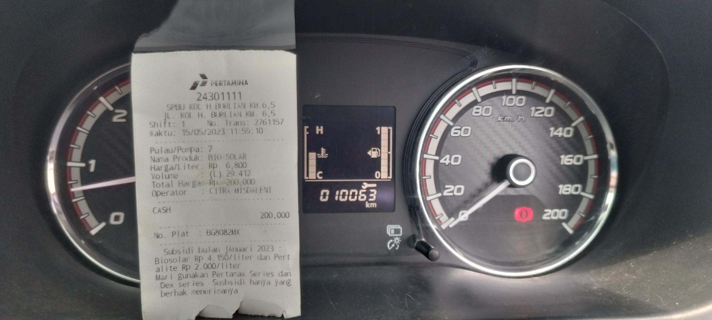

**NOTA SOLAR TGL : 15-05-2023. PLAT BG 8082 MX, KM 10063, RP 200.000.00. 29.41 LITER**

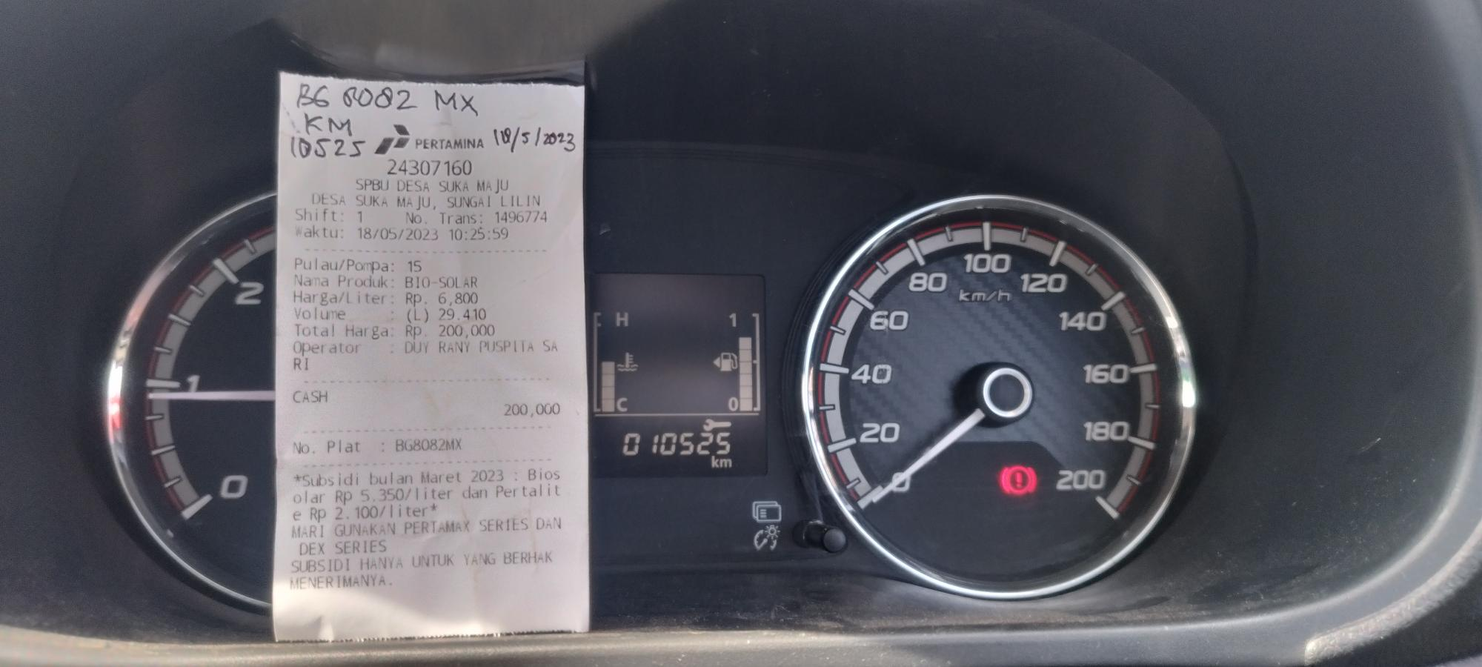

**NOTA SOLAR TGL : 18-05-2023. PLAT BG 8082 MX, KM 10525, RP 200.000.00. 29.41 LITER**

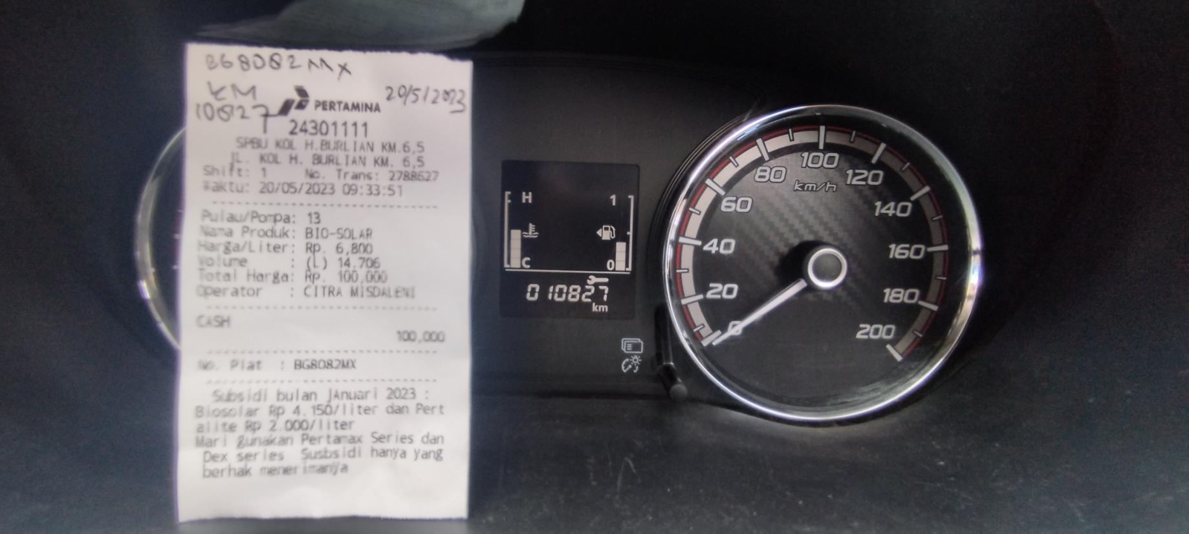

**NOTA SOLAR TGL : 20-05-2023. PLAT BG 8082 MX, KM 10827, RP 100.000.00. 14.70 LITER**

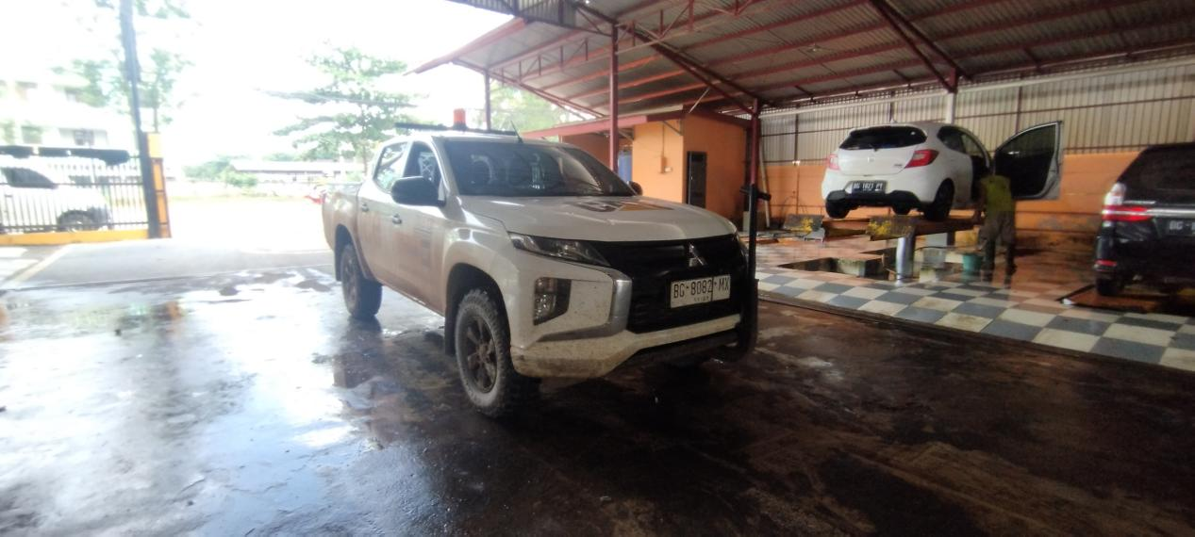

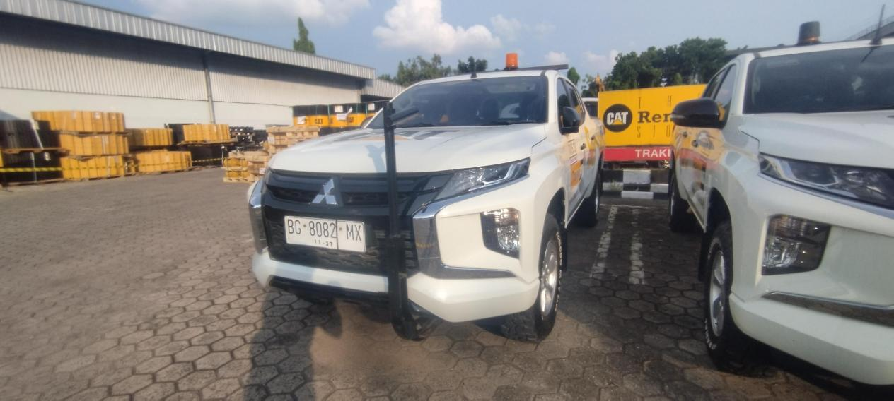

**CUCI MOBIL TGL : 20-05-2023. PLAT BG 8082 MX, RP 60.000.00**

**KONDISI SEBELUM DAN SESUDAH CUCI MOBIL**