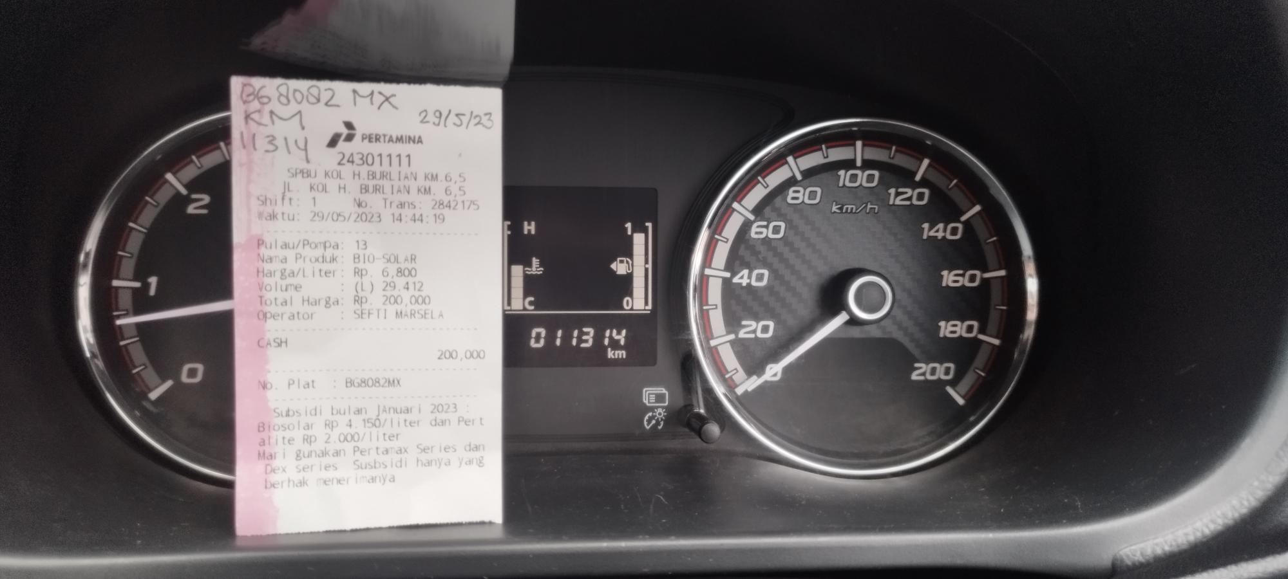
ISI FUEL SOLAR MOBIL SERVICE BG 8082 MX : KM 11314, TGL 29-05-2023

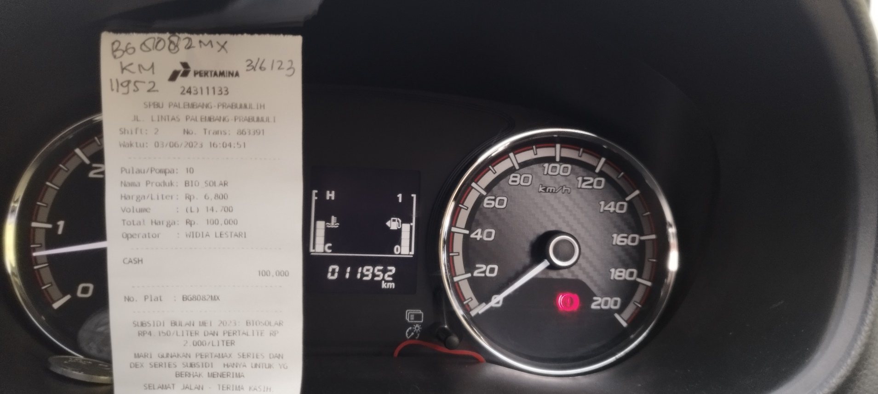
ISI FUEL SOLAR MOBIL SERVICE BG 8082 MX : KM 11952, TGL 03-06-2023
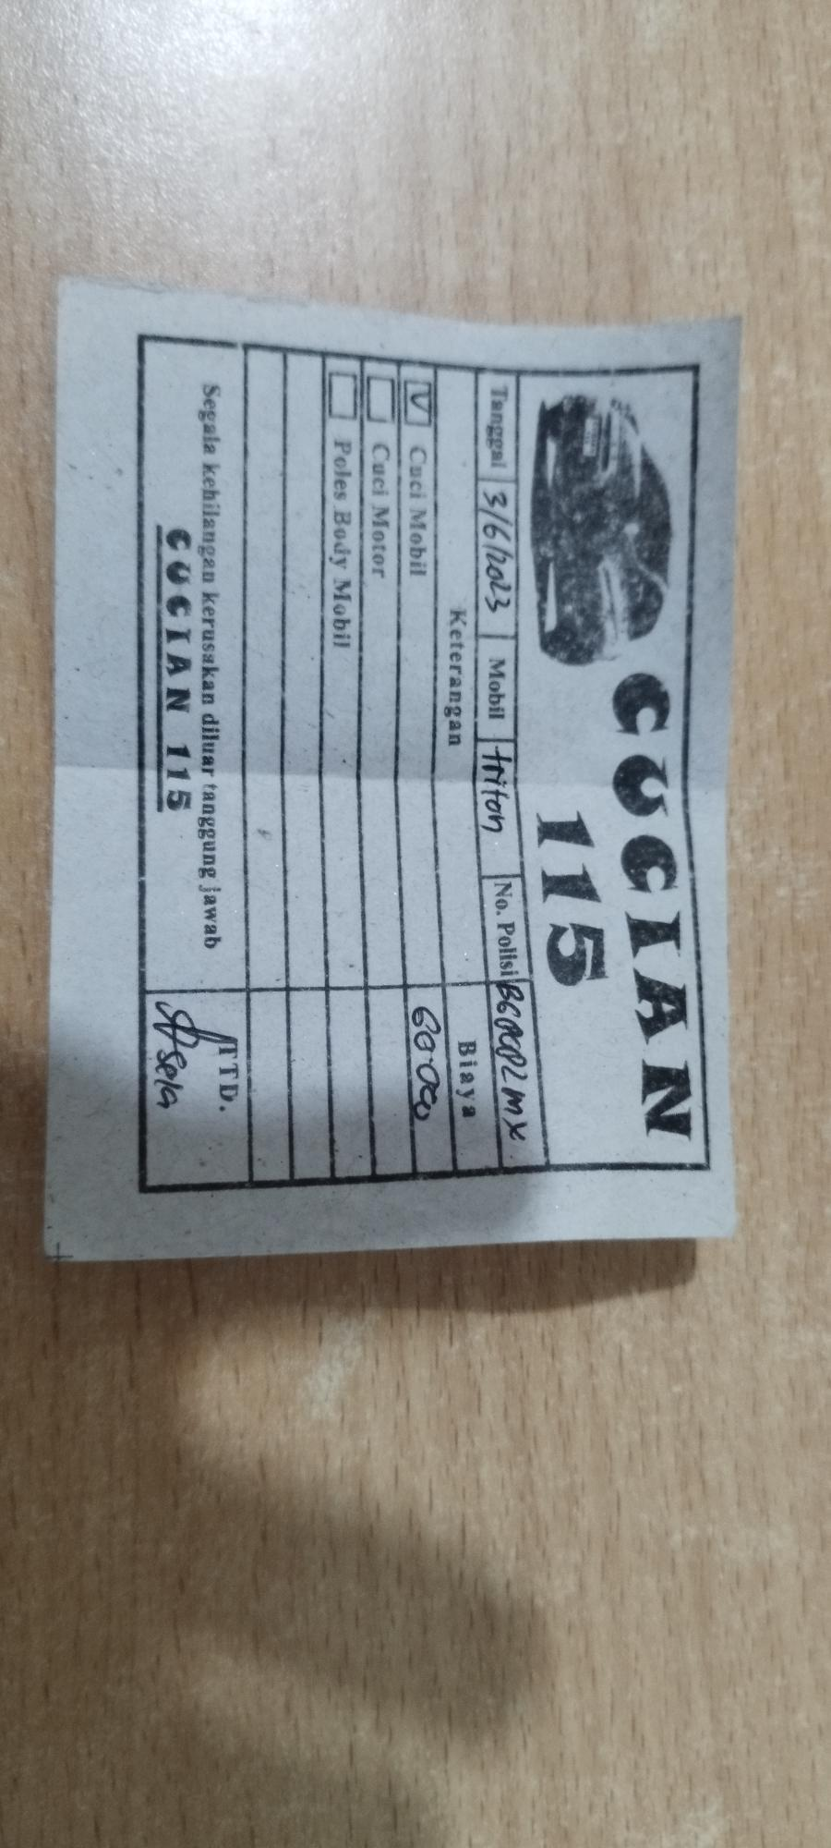
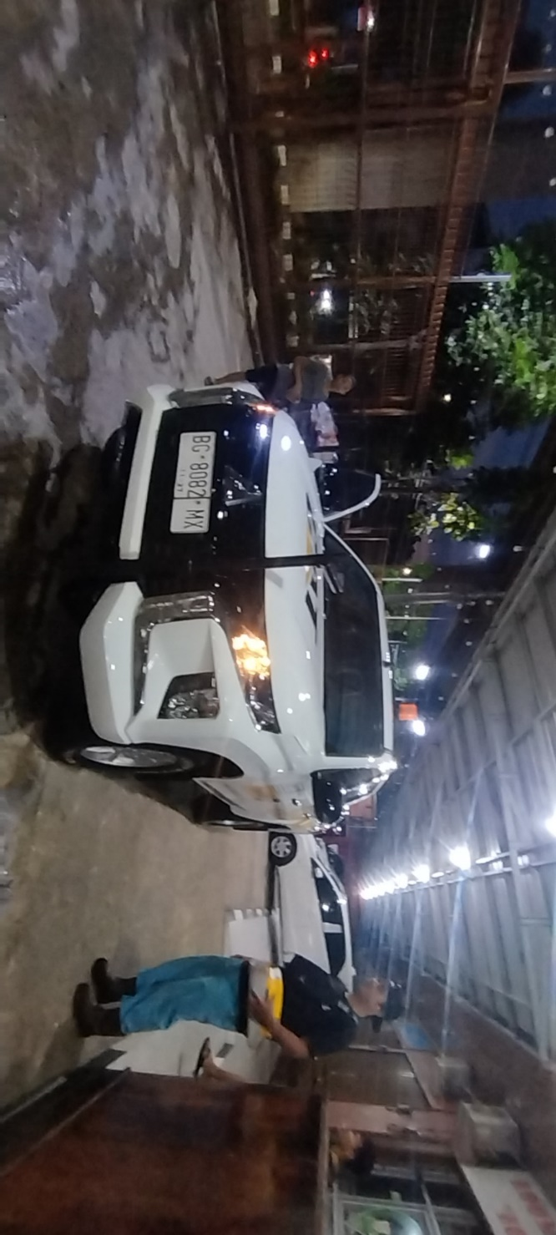
CUCI MOBIL SERVICE BG 8082 MX, TGL 03-06-2023. PULANG DARI LOKASI SEBELUM MASUK KANTOR

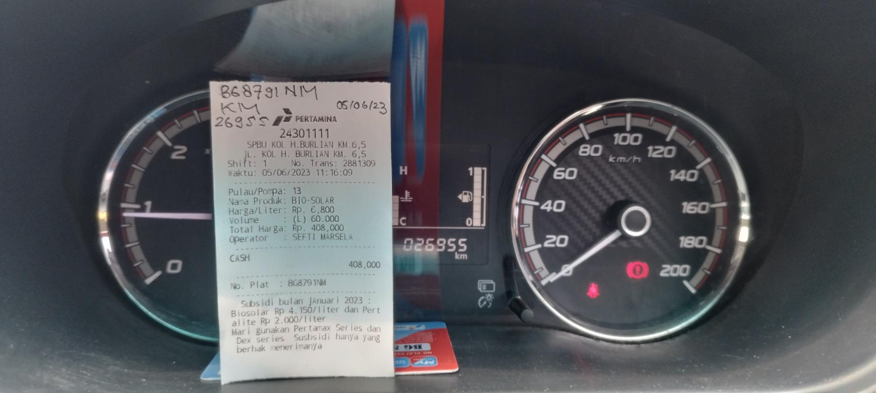
ISI FUEL SOLAR MOBIL SERVICE BG 8791 NM : KM 26955, TGL 05-06-2023

