NO | DATE | ACTUAL EXPENSE | NO POL | DESCRIPTION & KM LV | NO | DATE | ACTUAL EXPENSE | NO POL | DESCRIPTION & KM LV
1 | 30/01/2024 | RP 800.000 | BG8350DP | DEXLITE 53.69 LITER (KM 75849) | 2 | 03/02/2024 | RP 600.000 | BG8454IL | DEXLITE 40.2 LITER (KM 111250)
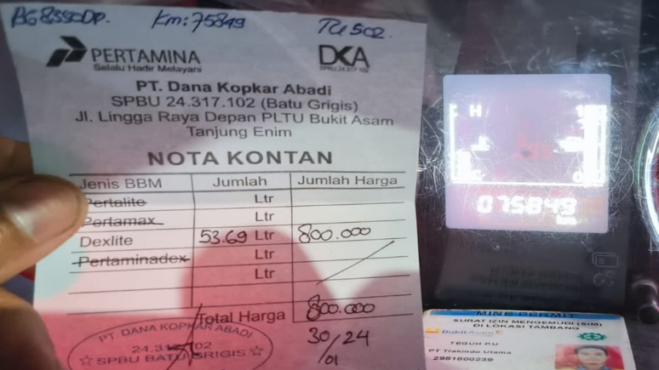 |  |  |  |  | 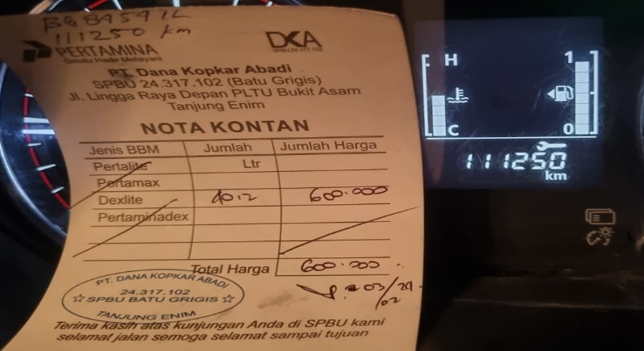
3 | 04/02/2024 | RP 800.000 | BG8163IL | DEXLITE 53.6 LITER (KM 58951) | 4 | 05/02/2024 | RP 700.000 | BG8350DP | DEXLITE 46.97 LITER (KM 76180)
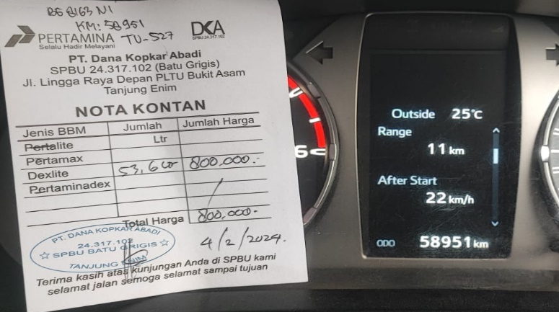 |  |  |  |  | 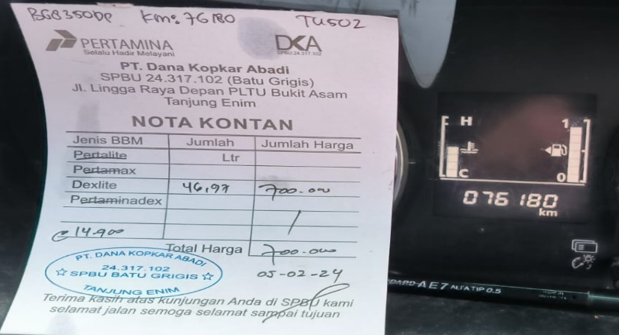
5 | 07/02/2024 | RP 780.000 | BG8454IL | DEXLITE 52.34 LITER (KM 111589) | 6 | 10/02/2024 | RP 700.000 | BG8350DP | DEXLITE 46.9 LITER (KM 76507)
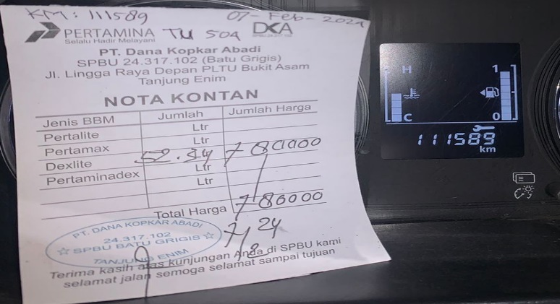 |  |  |  |  | 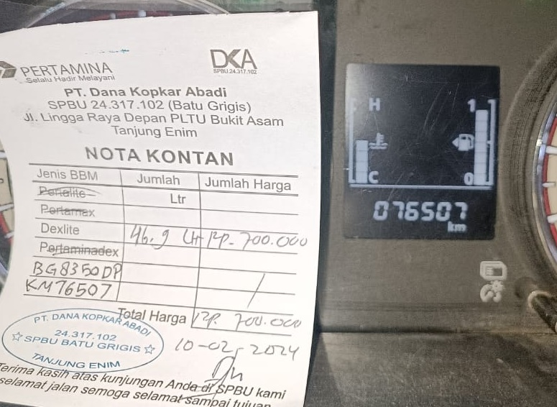
7 | 10/02/2024 | RP 500.000 | BG8832DQ | DEXLITE 33.5 LITER (KM 7236)
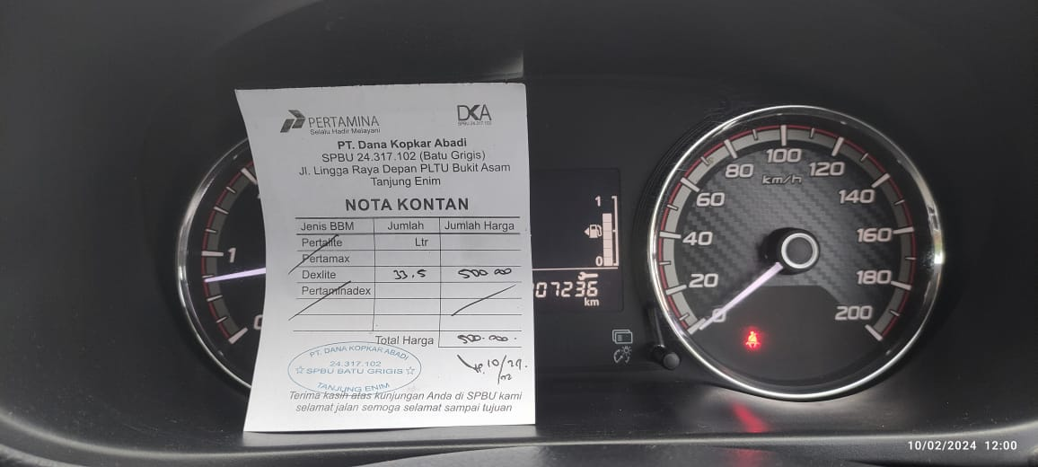
8 | 04/02/2024 | RP 120.000 | BG8163IL | WASHING CAR
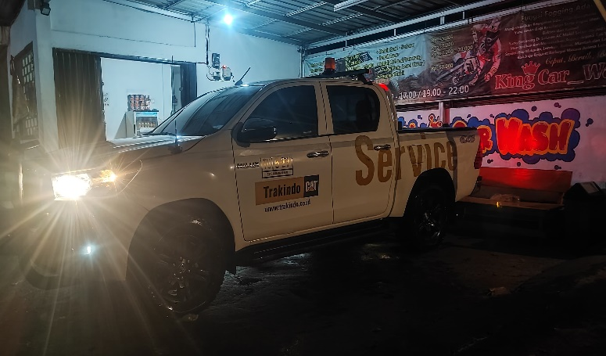 |  |  |  |  | 