23 Oktober 2023

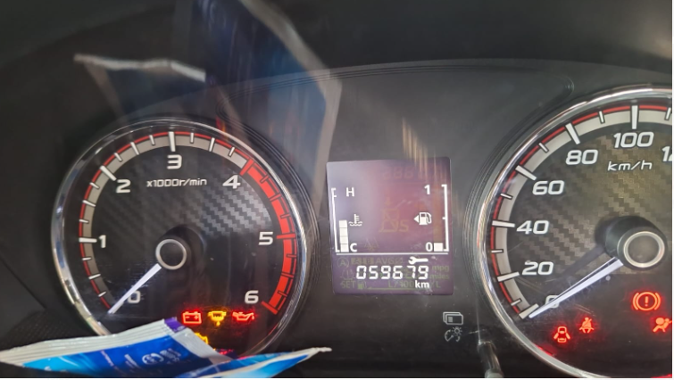

25 Oktober 2023

27/10/2023

