17 Oktober 2023

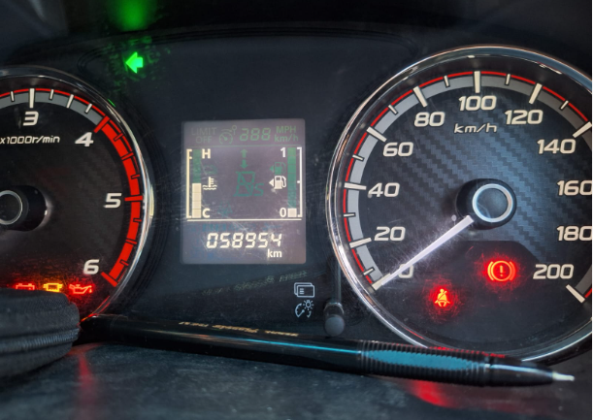 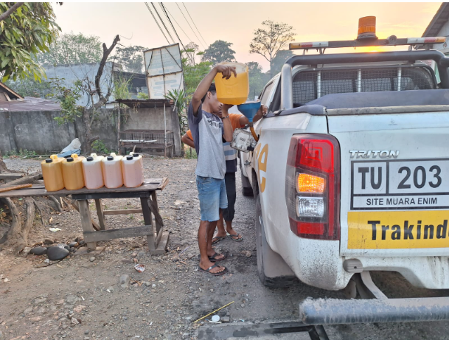

19 Oktober 2023

21 Oktober 2023

