**25 Maret 2023 – 300,000 (HM. 64681)**

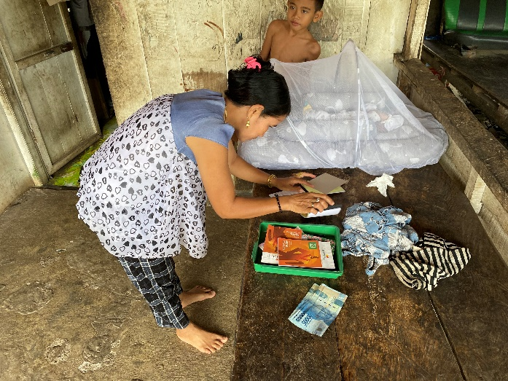

**7 April 2023 – 300,000 (HM 65149)**

