**5/6 2023 DT8529FE**

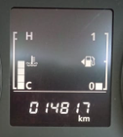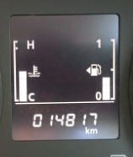

**8/6 2023 DT8529FE**

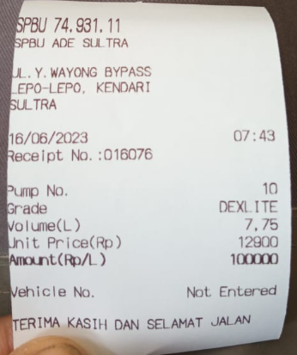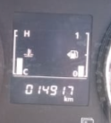

**16/6 2023 DT8529FE**

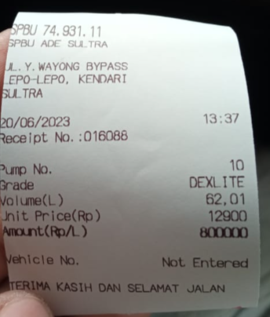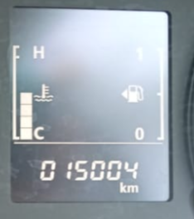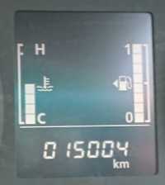

**20/6 2023 DT8529FE**

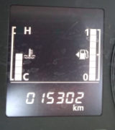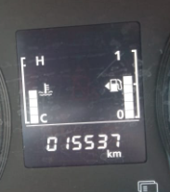

**25/6 2023 DT8529FE**

**23/6 2023 DT8529FE**

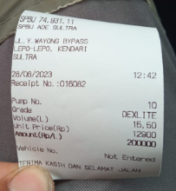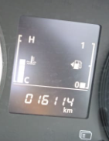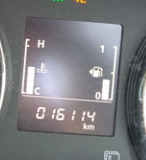

**28/6 2023 DT8529FE**

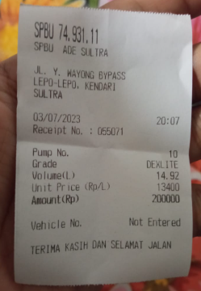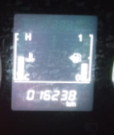

**3/7 2023 DT8529FE**

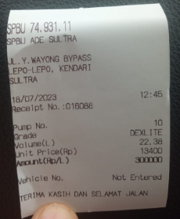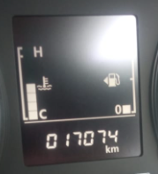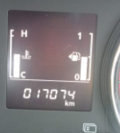

**18/7 2023 DT8529FE**

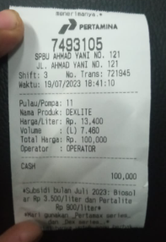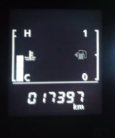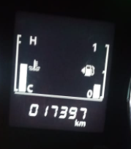

**19/7 2023 DT8529FE**

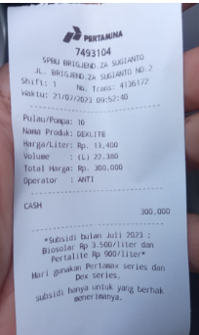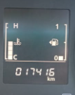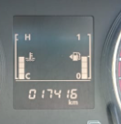

**21/7 2023 DT8529FE**

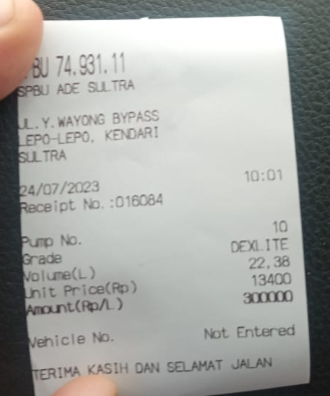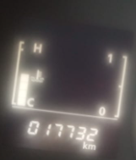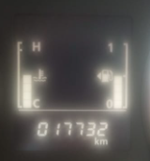

**24/7 2023 DT8529FE**

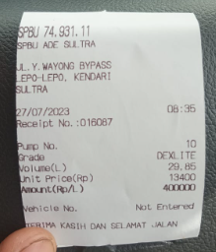

**27/7 2023 DT8529FE**

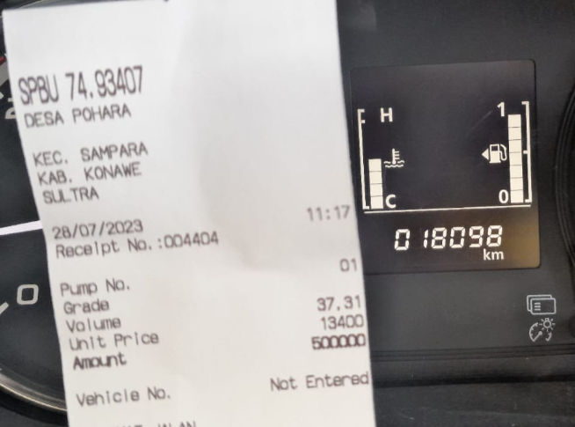

**28/7 2023 DT8529FE**

