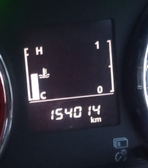 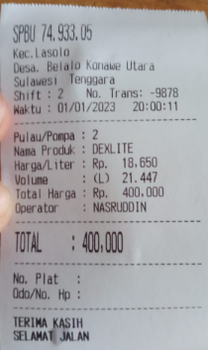

**DT9007KE 1/1/2023**

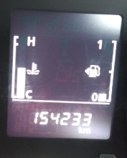 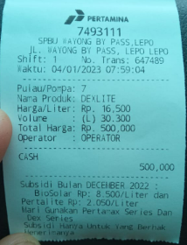

**DT9007KE 4/1/2023**

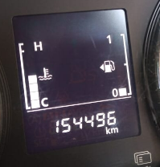 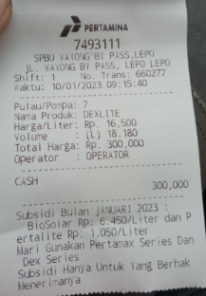

**DT9007KE 10/1/2023**

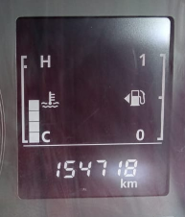 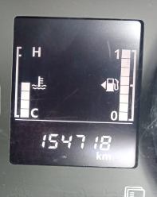 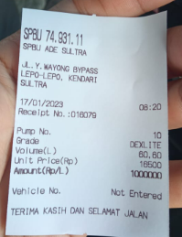

**DT9007KE 17/1/2023**

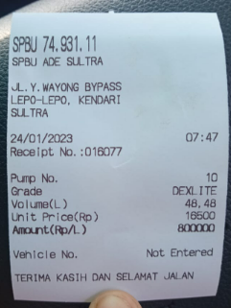

**DT8742CE 24/1/2023**

**DT8529FE 1/2/2023**

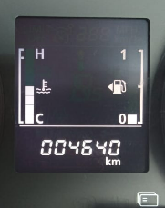

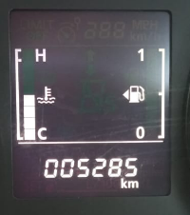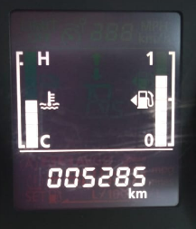

**DT8529FE 22/2/2023**

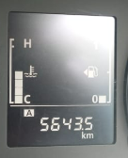 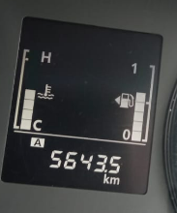

**DT8529FE 24/2/2023**

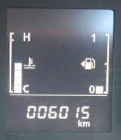

**DT8529FE 28/2/2023**

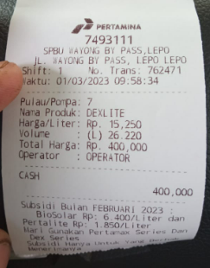

**DT8529FE 1/3/2023**

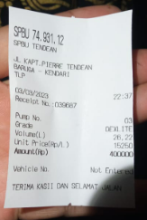

**DT8529FE 3/3/2023**

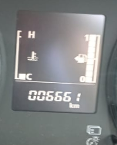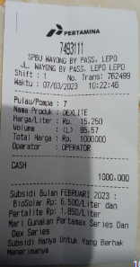

**DT8529FE 7/3/2023**