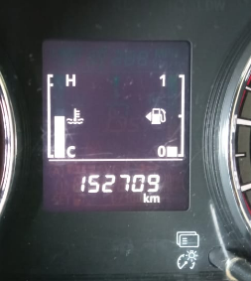

**DT9007KE 27/12/2022**

**DT9007KE 29/12/2022**

**DT9007KE 30/12/2022**