PERBANDINGAN SESUAI POH

BANJARMASIN – BALIKPAPAN JAM 09:50 WITA & 14:50 WITA

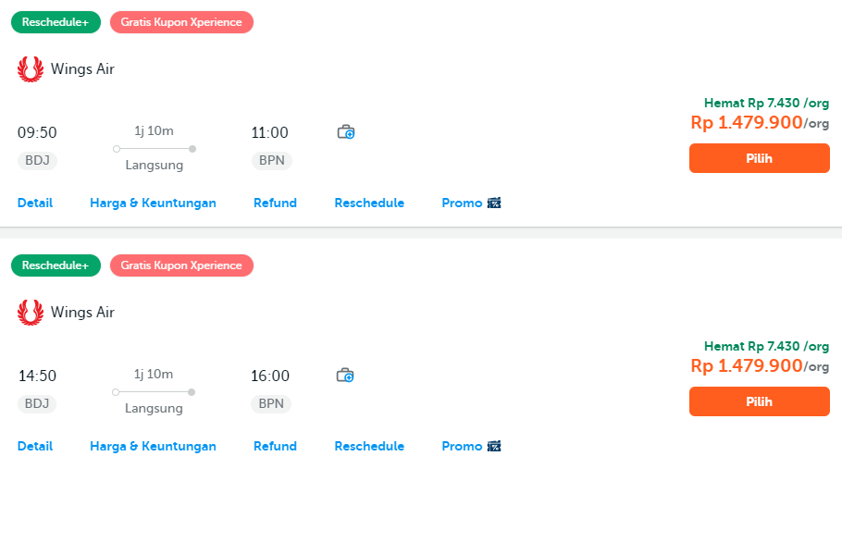

BALIKPAPAN- BANJARMASIN JAM 09:50 WITA & 11:20 WITA

